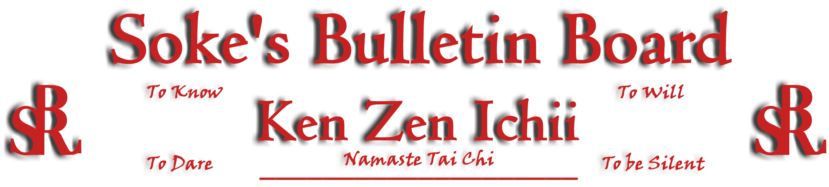
www.kenzenichii.com

March 2010
Promotions
Crush Fitness
Congratulations to Sensei Christopher Faris on earning the Blackbelt rank of Shodan
Congratulations to Nicholas Bisceglia on earning the rank of Yellow Belt

House of Soke II
Congratulations to Jake Carpenter on his promotion to the rank of Brown Belt
Congratulations to Zoe Brokaw on earning the rank of Yellow Belt
Congratulations to Zack Brokaw on earning the rank of Yellow Belt
Congratulations to Kevin Garcia on earning the rank of Yellow Belt

House of Soke II
Welcome new students Shawn Craig, Megan DuPriest and Alix Tuel.

Crush Fitness
Welcome new students Dawson Fort, Melissa Zarecki, Dylan Fort, Kayla Cuthbertson, and AnnaMaria Solanto

Congratulations to Jacob Moore on his outstanding academic excellence in 5th grade (100% average in math) and to Theo Haris Kyrou on his-straight A average.

BSR Modern Martial Arts School
Welcome new students, Kain'tre Torrence, Amariya Torrence, Zahir Williams, and Niyah Scott.

BSRMMA has moved to 3541 Dewitt Lane in Charlotte NC, 28217 (South End). Big thanks to all the brothers and sisters who helped make this possible. Grand opening will be announced soon. All BSR members welcome. Ous!

Two Skies School of Self Defense
The Two Skies School of Self Defense is going strong and wishes the KZI family the best.

Sapphire Dragons
All is well with the Sapphire Dragons.

Video Clip of the Month
Check out the latest video clip of the month: http://www.youtube.com/watch?v=X0hkTtwzJb4

If you are interested in posting a link, please forward it to Sensei Michael Calabrase at mcalabrase@bsrwarriors.com or the editor at noah_valle@hotmail.com.

Pearl’s of Wisdom
A wise woman who was traveling in the mountains found a precious stone in a stream. The next day she met another traveler who was hungry, and the women opened her bag to share her food. The hungry traveler saw the stone in the woman’s bag, admired it and asked the woman to give it to him. The woman did without hesitation. The traveler left rejoicing in his good fortune. He knew the jewel was worth enough to give him security for the rest of his life. But a few days later he came back searching for the woman. When he found her, he returned the stone and said, “I have been thinking. I know how valuable this stone is, but I give it back to you in the hope that you can give me something much more precious. If you can give me what you have within you that enabled you to give me the stone”…Sensei Baker

Editor’s Notes
Articles for the Ken Zen Ichii website and newsletter are being actively solicited. Anyone who wants to submit an article should contact Sensei Michael Calabrase at mcalabrase@bsrwarriors.com or the editor at Noah_Valle@hotmail.com, (818) 395-0757.

